Math 9 Linear Measurement (Imperial)
By Carley Brockway
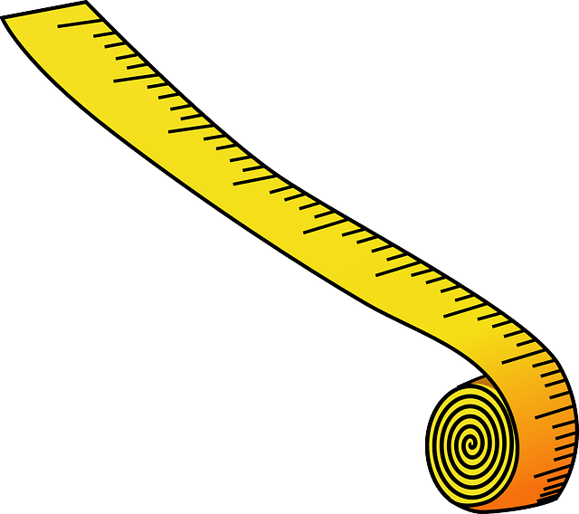

Employing the Sense of Mystery & Puzzles Tool:

(NOTE: This is a segment from an IE MA 9 unit—thanks for sharing Carley!)

…I want to begin the unit with a hands-on puzzle where students are challenged to build a rectangle out of 9 squares. After they complete the puzzle, I want students to prove that it is in fact a rectangle by measuring the length and width in inches (it is 32 by 33 inches). The students will draw out the rectangle and include the dimensions for each piece. At the end of the class, I will tell them about the background of this rectangle.

The MYSTERY: It was thought to be impossible to build a rectangle out of different sized squares but in 1925 a Polish Mathematician named Zbigniew Moron published an article that proved it was possible. He used 9 different squares and created a rectangle that was 32 x 33 (a time to discuss with the students the following: did the puzzle need to be 32 inches across?). His discovery continues to be the basis for many more mathematical questions. For example: What other perfect rectangles can built using more than 9 different squares? What patterns are there? What percentage of the squares to build the rectangle are perfect squares? Is there a maximum amount? What percentage are prime numbers? Does the smaller one always have to go in the middle?

Note: If time permits, or it is an honours level class, it would be interesting to challenge the students to generate the dimensions for the 32x33 inch rectangle by themselves and only tell them that it uses 9 different squares.

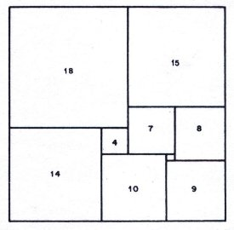
“The perfect rectangle”
Source: http://www.squaring.net/history_theory/z_moron.html

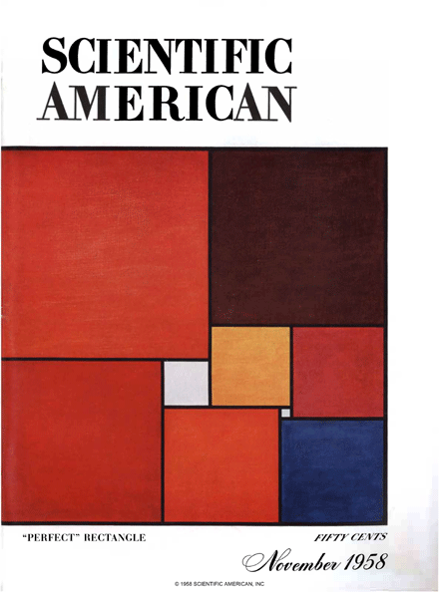
The “Perfect Rectangle”
Source: http://celebrationofmind.org/COLUMNS/miller-squares.html

MORE MYSTERY: The perfect square (a square made up of different sized squares) was thought impossible until 1978 when it was discovered by A.J.W. Duijvestijn. This perfect square is made up of 21 different squares. To date, this is the smallest quantity that has been discovered.
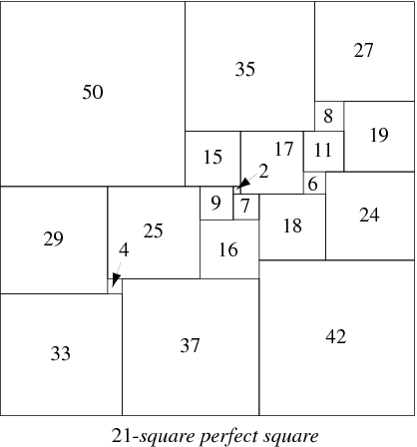
Source: http://mathworld.wolfram.com/PerfectSquareDissection.html

These puzzles lead nicely into Fibonacci numbers (1, 1, 2, 3, 5, 8, 13, 21, 34, etc.), Fibonacci Rectangles are also known as Golden Rectangles and the Golden Spiral. I will read the book “Wild Fibonacci” to my students and we will show them some images that illustrate this golden spiral. This spiral, is found in animals, plants, weather patterns, art, architecture, etc. I will put together a slide show of pictures showing the golden spiral and set it up to show on the projector as students enter the class.

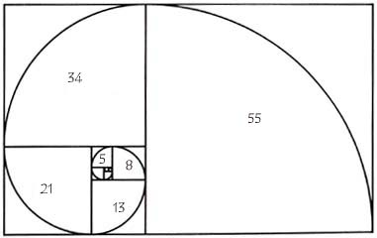
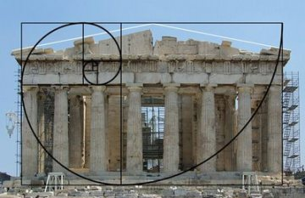

Like Zbigniew Moron, Fibonacci’s numbers continue to inspire mathematics. The Harriss spiral was recently discovered by a mathematician (2015) and it echoes properties and proportions found within the Fibonacci spiral.
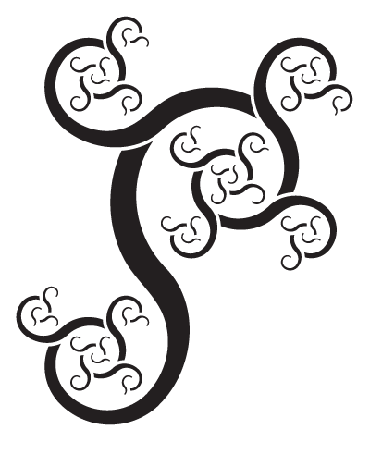
Source: http://www.theguardian.com/science/alexs-adventures-in-numberland/2015/jan/13/golden-ratio-beautiful-new-curve-harriss-spiral

MORE PUZZLES: On a different note, I will also use puzzles to practice skills such as equivalent fractions (16 pieces that fit together based on sides that have equivalent fractions). Students will be able to work together to find matching pieces and solve the puzzle.

As we progress through the unit and become more comfortable with yards and with conversions between units, I will bring forward an unsolved question that was actually generated by a former student during a lunchtime conversation with me earlier this year. This is what he said”
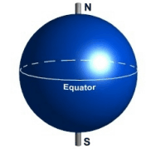versus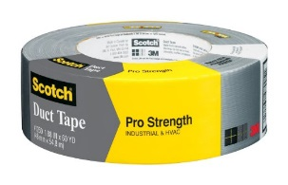
“I wonder how many rolls of duct tape would you need to wrap all the way around the Earth?”

Great question, I said! Let’s figure it out: The circumference around the Earth at the equator is about 25, 000 miles and one roll of duct tape is 60 yards. Once they have this answer, we’ll take it one step further and figure out how much this would cost if one roll of 60 yard duct tape costs $16.90 at Staples (this involves rounding, but not to the rounding “rules” because you can’t buy half a roll of duct tape – and challenges locked in concepts: yes, you round up to the next digit if the one to the right is 5 or more… but not always!). We would also discuss assumptions that we are making (ex. mountains, oceans, stretchy duct tape, etc.).

At the end of the unit, I want to show the students a little video on the mysterious pyramid supposedly found in the Bermuda triangle. I doubt that this claim of an underwater pyramid is legitimate, but it’s interesting and the thought that triangles are part of a conspiracy claim make it intriguing.

The base of this pyramid supposedly measures approximately 985 feet. This is the perfect opportunity to review conversions (would it be easier to estimate if we thought of it in yards?) and have the students predict how far this actually in respect to our school hallways and then actually measure it (the school is approximately 520 feet long).
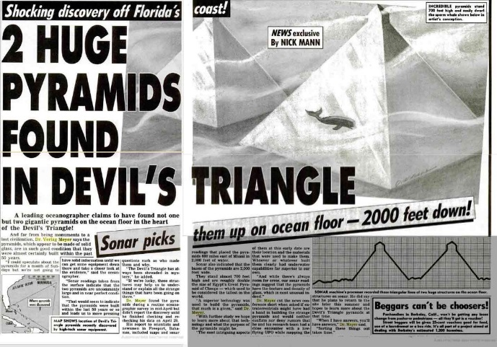
Source: http://www.apparentlyapparel.com/news/pyramids-of-glass-submerged-in-the-bermuda-triangle

