5 Ways You Can Grow Your Brain
(Tips For Writing Your Next SS Report)

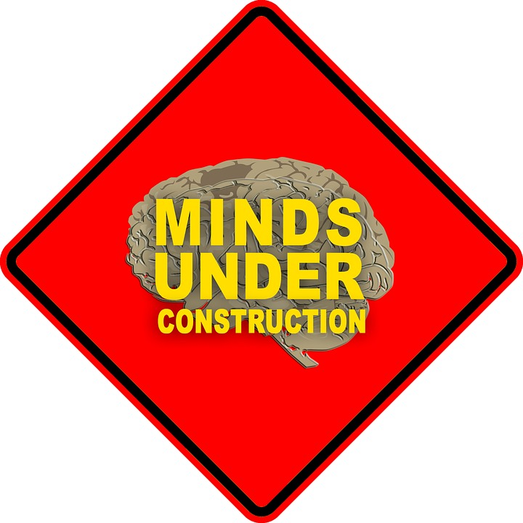

1. FORMALITY. This is a FORMAL report! YOU and I are not invited to the party!!! Invited only: THEY and WE and US!

2. THESIS STATEMENTS
Theses can only live in sentences that make sense. These statements will die a slow painful death if they are not in a sentence. This death will be even more painful if any of your subtopics are left out or if the thesis doesn’t get to go last in the first paragraph and first in the last paragraph.

3. TRANSITIONS
I will get lost in your report if you don’t have TRANSITIONS between paragraphs and if they’re not at the BEGINNING of your paragraphs. I don’t like getting lost - it makes me anxious. When I find transitions in the wrong place or if they are missing, I feel like I need to call out the search and rescue.

4. ANSWERS, NOT QUESTIONS. Please do not put questions in your report. If you still have questions, that’s a problem. Your reader wants firm statements – s/he wants to know that you have all the answers!

And last but not least…

5. CLINCHERS. You will end your report with a BANG if you can connect your topic to life TODAY - or perhaps to the FUTURE. Your report will end with a whimper if you end with a question or if you just repeat what you’ve already said. And I will whimper too……

